**Question No 1:** Business Intelligence (BI) is being considered about getting the right information to the right decision-makers, at the right time. Describe the common types of decisions and trends of business intelligence used by organizations for competitive advantages.

# **What is Business Intelligence?**

## **BI Helps You:**

* Collect proprietary business data
* Blend data from a variety of sources
* Create intuitive visualizations of datasets
* Discover data trends and patterns
* Glean insights from data
* Make informed, data-driven business decisions

**Collect proprietary business data**

Regardless of whether you understand it, your association is creating information continually. Previously, all of this data would have essentially disappeared as squandered potential.

With the utilization of BI apparatuses, that important crude information can be gathered, put away, coordinated, and organized into usable data.

This information can integrate a scope of data types. A few sorts of information clients ought to consider gathering are:

This data can incorporate a range of information types. Some kinds of data users should consider collecting are:

* Sales metrics
* Customer demographics
* Employee quotas
* Social media followers
* [Social media engagement](https://www.selecthub.com/business-intelligence/social-media-business-intelligence/)
* Customer behavior data
* Retention rates
* Conversion rates

These are by no means the only kinds of data you can begin to utilize through business intelligence, but they are some of the most common.

### Blend data from a variety of sources

One more key part of business knowledge is where it draws generally that information from. BI draws information from an assortment of sources and mixes it into a durable pool in the client's information stockroom. These sources come in three configurations: unstructured, and semi-endlessly organized.

### Unstructured

Such information is any sort of information that isn't coordinated into a social data set. It tends to be challenging to move straightforwardly into data clients can decipher, yet it doesn't need to be. Around 90% of information is unstructured and should be put through some sort of hierarchical cycle to be usable. A few instances of this kind of information are:

* PDFs
* Images
* Videos
* MP3s
* Movies
* Emails
* Websites

### Semi-Structured

This is an in-between category. If a dataset isn’t necessarily organized into a relational database but also isn’t completely unorganized. It typically has some sort of regulation system that makes it easier to analyze without putting it into rows and columns. Some examples of semi-structured data sources include:

* XML documents
* NoSQL databases
* JSON
* MongoDB
* CSV

### Structured

Likewise, some of the time alluded to as social information, organized information is included effectively classifiable data put away in a social data set like telephone numbers, postal divisions, charge cards, birthdates, and other data that squeezes into effectively pre- characterized fields. Somewhere around 5-10% of all information is organized before being put through a calculation or programming framework.

Some examples of structured data sources are:

* CRMs
* ERPs
* MySQL
* DB2
* MSSQL

Business intelligence can draw unstructured, semi-structured, and structured data from these different sources and blend them into usable data in an organization’s data warehouse.

### **Create intuitive visualizations of datasets**

When the information is tidied up and organized, BI programming can create graphical portrayals of the information. It does this by making a perception of the information as a scattergram, structured presentation, pie diagram, and so on.

Numerous BI arrangements give a best-match idea to assist clients with choosing the representation type that will best portray the sort of information. For instance, a pie outline works best if the information is addressing segments of an entire, structure, structured presentations lasting one variable against a couple of others, and so on.

### Discover data trends and patterns

These representations assist clients with uncovering examples and patterns in the information. As an essential model, envision a scattergram of your association's marketing projections diagrammed against the 50 U.S. states. While you could recognize designs in the report that main gives you gives per express, that data portrayed graphically makes contextualizing those numbers substantially more natural.

The human mind deciphers visual information considerably more rapidly than conceptual mathematical information, so this interaction speeds up the chance to understand and makes information examination open for clients from a scope of specialized abilities and foundations.

### Glean insights from data

Since you have this speculative diagram of your business' deals in each U.S. state, you can utilize the examples portrayed in the representation to gather experiences. Suppose your deals are for the most part great in the West, yet poor in Washington and Oregon.

What could represent this error? Is there a business opportunity for your item or administration that you're not completely making the most of? Is it true that you are squandering assets on a district that doesn't require your item or administration? You can pose these sorts of directed inquiries to uncover new data and experiences in your business that could not have possibly been as clear without BI applications.

### Make informed, data-driven business decisions

Proceeding with our model, you know that deals are poor in the Pacific Northwest locale of the U.S. You can utilize this data to shape your business methodology as you continue. Do

you have to focus on another market? Do you have to put more into promoting? Numerous BI apparatuses offer estimating highlights that let clients run situations in light of various techniques. These utilize verifiable information to foresee future outcomes, permitting you to test theoretical systems before completely executing them. Organizations that settle on information-driven choices will generally be more sure, more fruitful, and more in charge of their way.

## TYPES OF DECISIONS

### Three primary types of business intelligence decisions

Business intelligence supports the three types of decision-making mentioned above: strategic, tactical, and operational. Its frequency and organizational impact characterize each.

### **Strategic decisions**

Strategic decisions comprise the highest level of organizational business decisions, and are usually infrequent and made by the organization’s executives. Yet, their impact is enormous and far-reaching.

Some types of strategic decisions include selecting a particular market to penetrate, a company to acquire, or whether to hire additional staff.

Decisions made at this level usually involve significant expenditure. However, they are generally non-repetitive and are taken only after careful analysis and evaluation of many alternatives.

### Tactical decisions

Tactical decisions occur with greater frequency (e.g., weekly or monthly) and fall into the mid-management level. Often, they relate to the implementation of strategic decisions. Examples of tactical decisions include product price changes, work schedules, departmental reorganization, and similar activities.

The impact of these types of decisions is medium regarding risk to the organization and impact on profitability.

### Operational decisions

Operational decisions usually happen frequently (e.g., daily or hourly), relate to day-to-day operations of the enterprise, and have a lesser impact on the organization. Operational decisions determine the day-to-day profitability of the business, how effectively it retains customers, or how well it manages risk.

**Answering a sales inquiry, approving a quotation, or calculating employee bonuses may be examples of this decision type.**

**You can summarize these types of decisions in business intelligence this way:**

**Strategic –** Long-term, complex, made by senior managers;

**Tactical –** Medium-term, less complex, made by mid-level managers;

**Operational –** Day-to-day, simple, routine, made by junior managers.

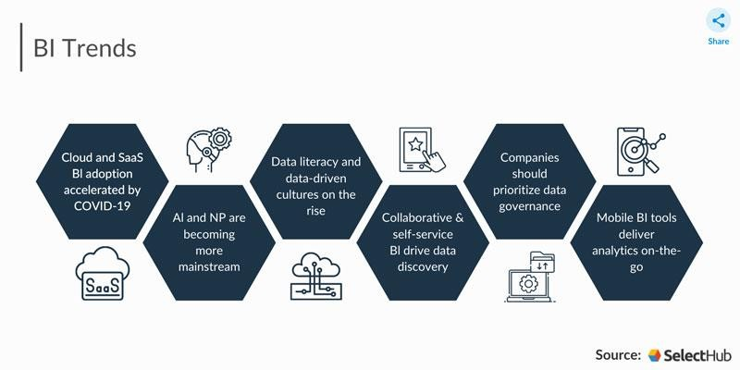

## Top Trends

### SaaS and Cloud Adoption

The COVID-19 pandemic put organizations and enterprises in crisis mode as they mixed to sort out the circumstance. With on-premise arrangements incapable to compare the test of a generally distant labor force, numerous organizations had to look closely at their ongoing BI methodologies. More associations look to move to cloud-based BI this year, whether on a private or public cloud or SaaS arrangement.

Many organizations are realigning their financial plans present pandemic on account of embracing the cloud framework in the move towards remote and unique labor forces. Gartner predicts that by 2023, 40% of all venture jobs will be conveyed in the cloud, up from 20% in 2020. Organizations presently consider examination a crucial capacity, and organizations aren't avoiding taking on information arrangements.

Mike Brody, CEO of Exago, a product merchant for implanted BI for SaaS suppliers, said their organization adjusted rapidly to the change to remote work; as a matter of fact, it's flourishing.

### **Data Literacy**

Organizations are starting to comprehend the significance of carrying out information investigation all through their association. Rather than isolating examination and direction, organizations are presently hoping to put experiences first. They maintain that information should illuminate all their choices, from defining objectives to creating systems and lastly making a move.

In any case, to do as such, they have first to layout and develop a solid groundwork of information proficiency. What is informal education? As per Gartner, it's the capacity to peruse, compose and impart information in a setting - to lay it out plainly, the capacity to "talk information." It's a vital aspect for expanding client reception and amplifying the viability of BI devices. Information proficiency is significant for all people, independent of their work profile and organizations.

Having the option to decipher the information, find experiences, and pose the right inquiries are abilities that can drive change in any job at any level of any association. Information- driven entrepreneurs need to dispense with the information proficiency hole between information examiners and non-specialized clients, a cycle known as information democratization.

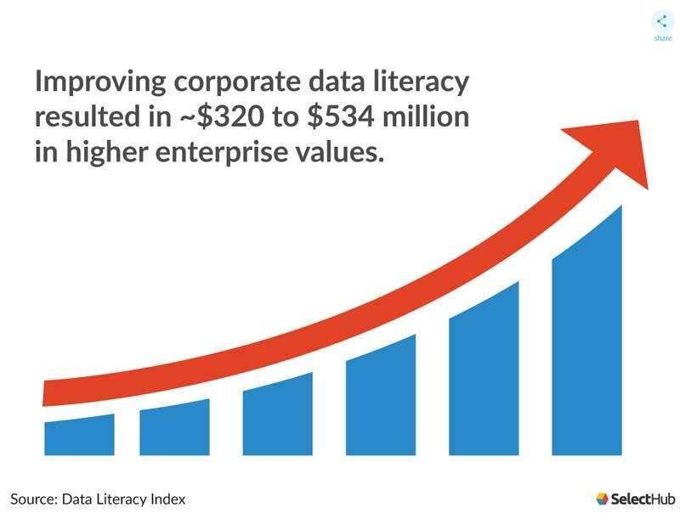

### Data Governance

According to a [Business Application](https://bi-survey.com/top-business-intelligence-trends) Research Center survey, metadata and data quality management with information governance rank in the top significant BI trends for 2022. Data governance ensures the quality of business assets through role-based access, authentication protocols, and auditing. When data is accurate, unique, and up-to-date, users trust the insights are reliable, boosting revenue and reputation.

The global data governance market [is projected to grow from $1.2 billion in 2016](https://www.maximizemarketresearch.com/market-report/global-data-governance-market-key-trends/6629/) to $4.9 billion in 2026 at a CAGR of 22.6%.

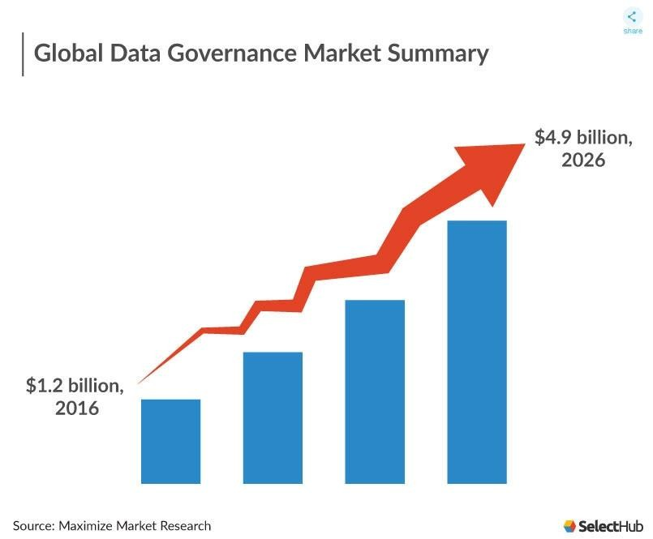

### Moving Towards Mobile

With moving work examples and business requests because of COVID-19, organizations overall are hoping to furnish their telecommuters with efficiency upgrading programming. These incorporate SaaS answers for admittance to reports and dashboards whenever anyplace. As indicated by Mordor Intelligence, the versatile business insight market is supposed to develop with a CAGR of 22.4% by 2024.

While most web clients access the web through a versatile, a piece of the pie isn't the main motivation to carry out portable BI. Clients can pick to get KPI-based cautions and respond immediately to occasions as they occur. Portable BI includes a responsive, light form of the primary examination stage, setting the force of experiences straightforwardly in the client's hands any place they go.

This on-request accessibility of data empowers quicker direction, more limited work processes, and more powerful inward correspondence. Although restricted screen size and usefulness can be prohibitive, the portable examination is a game-changing pattern in

business knowledge. Versatility is important for some product sellers' contributions in light of organizations' BI prerequisites records for 2022.

### Autonomous BI

Self-administration BI engages clients of all specialized abilities to get the information they need and use it. Groups can sort and investigate information through impromptu revealing, don't bother sitting tight for bits of knowledge from the IT group. Out-of-the-container information connectors, natural points of interaction, and pre-planned work processes in big business BI apparatuses let customary clients accomplish more with their information without specialized help.

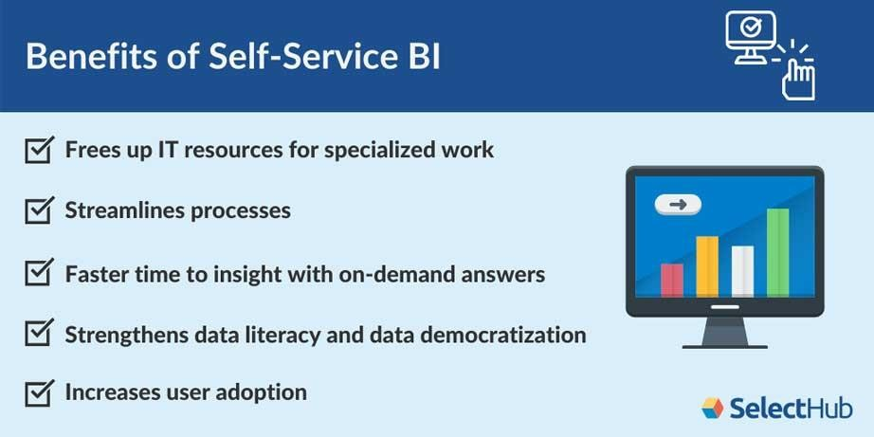They can perform information science errands like key driver investigation, consider the possibility that situation reproduction, and prescient examination through NLP. Information researchers can use ML-supported, low-code programming and interoperability to foster applications and coordinate them with business stages. Examination and information science jobs are covered currently, because of more noteworthy independence being perhaps the main BI pattern.

Brody said that Exago was established on the ideas of information democratization and self- administration announcing, however they never pondered it like that at that point. As per Brody, a portion of Exago's clients have a huge number of end clients, each with the capacity to make their reports and control their information.

### Data Visualization and Storytelling

Narrating and instinctive visuals are connected with ways of assisting clients with figuring out basic experiences. Information representation transforms business data into designs and outlines that clients view as more obvious than blocks of message and numbers. Information narrating places information into a setting by building a story around basic measurements, whether through dashboards, intuitive reports, or delightful visuals.

Dashboard programming is advancing from straightforward KPI checking to inside and out information investigation through intuitiveness and increased examination.

With AI-ML, clients can demand data in normal language and view the outcomes in a straightforward organization. They can connect information with a setting to distinguish where to concentrate out of nowhere and make cautions for information changes.

Coordinated effort empowers data makers and shoppers, and outside partners to cooperate in a solitary, unified center.

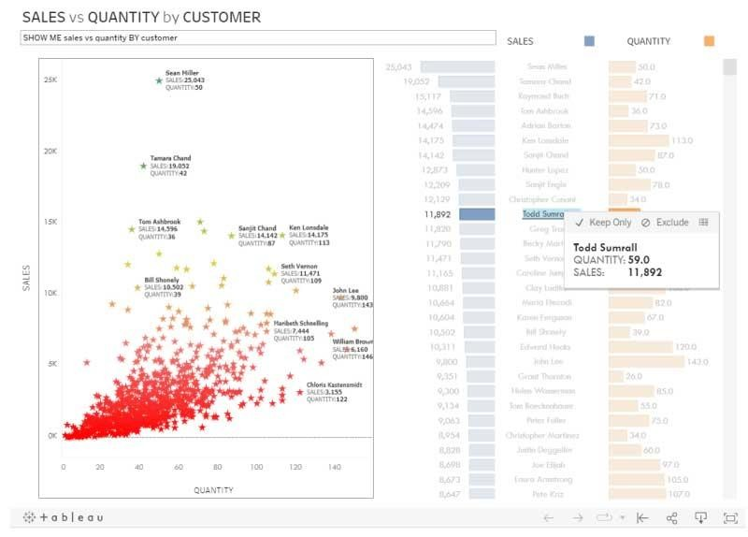

**Question No 2:** Electronic payment processes is being considered a key components of an e-commerce process architecture. Why it is a key component. What strategies can be adopted to make e-commerce process secure and successful?

# E-Commerce

The second that a trade of significant worth happens, e-business becomes a web-based business. Internet business is the income generator for organizations that decide to utilize the Internet to sell their labor and products. A few independent ventures depend on the Internet to develop and get by. Numerous private ventures likewise seek online business for their own business needs, like PCs and office innovation, capital hardware and supplies, office decorations, stock for the online deal, or other business-related products. This isn't shocking thinking about the inescapability of the Internet for deals of every kind.

## Types of E-Commerce

Each Internet business is either unadulterated play or block and snap. An unadulterated play business, like Amazon and Zappos, has a web-based presence just and utilizes the capacities of the Internet to make another business. Block and-snap organizations, like Barnes and Noble and Vermont Country Store, join an actual presence with an internet- based presence. These organizations utilize the Internet to enhance their current organizations.

There are several different types of e-commerce. A common classification system is concerning the nature of transactions or the relationships among participants. There are seven major types of e-commerce:

1. **Business-to-business (B2B):** E-commerce, where businesses focus on selling to other businesses or organizations, is the largest form of e-commerce. Cisco, Staples, and Spiceworks (information technology [IT] and IT networks for the small- and medium- sized business) are all B2B companies.
2. **Business-to-Consumer (B2C):** This is the earliest form of e-commerce, but it is second in size to B2B. It refers to retail sales between businesses and individual consumers. Consumers gather information; purchase physical goods, such as books and clothing; purchase information goods, such as electronic material or digitized content, such as software; and, for information goods, receive products over an electronic network.
3. **Consumer-to-consumer (C2C):** E-commerce is where consumers sell products and personal services to each other with the help of an online market maker to provide a catalog, search engine, and transaction-clearing capabilities so that products can be easily displayed, discovered, and paid for. The most well-known C2C business is eBay, but there are many other online market makers as well. [Craigslist](http://www.craigslist.org/) is an extremely popular small e-commerce business for placing classified ads.
4. **Business-to-Government (B2G):** E-commerce can generally be defined as transactions with the government. The Internet is used for procurement, filing taxes, licensing procedures, business registrations, and other government-related operations. This is an insignificant segment of e-commerce in terms of volume, but it is growing.
5. **Consumer-to-Business (C2B):** E-commerce is between private individuals who use the Internet to sell products or services to organizations and individuals who seek sellers to bid on products or services. [Elance](http://www.elance.com/) is an example of C2B where a consumer posts a project with a set budget deadline and within hours companies and/or individuals review the consumer’s requirements and bid on the project. The consumer reviews the bids and selects the company or individual that will complete the project. Elance empowers consumers around the world by providing the meeting ground and platform for such transactions.
6. **Mobile commerce (m-commerce):** Refers to the purchase of goods and services through wireless technology, such as cell phones, and handheld devices, such as Blackberries and iPhones. Japan has the lead in e-commerce, but it is expected to grow rapidly in the United States over the next several years. eMarketer predicts mobile content revenues will grow to more than $3.53 billion in 2014, a compound annual growth rate of nearly 20 percent for the period 2009–2014, with the fastest growth coming from mobile music.
7. **Peer-to-peer (P2P):** Technology makes it possible for Internet users to share files and computer resources directly without having to go through a central web server. P2P began with Napster offering free music downloads via a file-sharing system. launched the world’s first P2P commerce system in 2005, which allowed people to sell every type of digital media directly from their computers to customers all over the world. People who publish videos, photos, music, e-books, and so forth can earn royalties, while buyers earn commissions for distributing media to others.

## E-Commerce Strategy

### Increase eCommerce Search Usability

Does your eCommerce stage record or examine what clients are looking for? Assuming your web-based store framework can follow this, you are presumably having a viable route and searchability.

To enhance the UX of your internet based store much more, coordinate your web store for these two fundamental gatherings of likely clients:

* + Guests who know what they need to purchase.
  + Guests who just need to peruse.

Clients who know the precisely exact thing they are searching for need to track down the right data as fast as could be expected. Planning a high-performing search experience is a vital element for your clients since, supposing that clients can't find what they are searching for, they will get it from another store.

The subsequent classification is potential clients who simply need to peruse the web- based store and think about things. They will utilize route menus and move between item classes and pages. To make their experience smooth, sort out the menu bar and classes in natural simple to-utilize areas.

Your site's hunt and route capacities should be very much planned and client situated to be successful and assist with further developing the general experience clients have on your eCommerce site.



To boost conversions as part of your eCommerce strategy you can improve the search usability in the following fields:

* + Design and behavior of the search field.
  + Search scope selection.
  + How should the autocomplete be designed?
  + Results layout and features.
  + Filtering and sorting the search results on the results page.

### Use High-Quality Photographs and Good Product Descriptions

Top-notch item pictures and photographs are a fundamental piece of your eCommerce computerized system and important for drawing in the consideration of potential eCommerce clients. Outside the physical world, purchasers can't contact the item and are pursuing their purchasing choices subject to item symbolism and criticism.

Showing great visible thumbnails on the query items page will assist clients with tracking down the ideal item in a single tick and get a superior thought of what you are advertising.

Furthermore, make your item depictions compact and focused. Keep away from cushions and make a thorough rundown of elements and advantages. Your objective clients need to have a deep understanding of a possible buy and how this item would help them and work on their regular daily existence, and keep this a steady subject in your eCommerce computerized procedure.

### Consider these tips when writing product descriptions:

* + Create proper subheadings.
  + Use bullet points to attract attention.
  + Improve readability with larger font sizes.
  + Provide video and real photographs of your product.
  + Pay attention to white spaces through the content to make the copy more readable.

[Website design](https://devrix.com/tutorial/web-design-trends-2021/) and [content creation](https://devrix.com/tutorial/how-to-create-high-quality-content-for-better-ranking/) should work together for optimal results. Make your website copy part of your whole UX experience and enjoy [higher conversion](https://devrix.com/tutorial/website-design-conversions-online-store/) [rates](https://devrix.com/tutorial/website-design-conversions-online-store/) right away.

If you want to perfect your product descriptions you can check “[How to Write](https://devrix.com/tutorial/how-to-write-ecommerce-product-description-best-practices/) [eCommerce Product Description: Best Practices](https://devrix.com/tutorial/how-to-write-ecommerce-product-description-best-practices/)” and try out some of the suggested practices.

### Text, letter Description automatically generatedTry Personalizing the Home Page

Personalization is a strategy that records what clients saw or visited during their keep going meeting on your eCommerce site and makes new purchasing ideas on each following visit in light of previous involvement with the store. This can be a

personalization given past conduct like past buys or in light of ongoing information like an area or time.

59% of online shoppers believe that it is easier to find more interesting products in personalized online retail stores”, invespcro.com, Online Shopping Personalization – [Statistics and Trends](https://www.invespcro.com/blog/online-shopping-personalization/)

[Amazon](https://www.amazon.com/) is the pioneer of the **user-centric shopping experience**. Their homepage helps people easily find the right product in the personalized block in the first section when you log in under the “related to items you’ve viewed” tag.

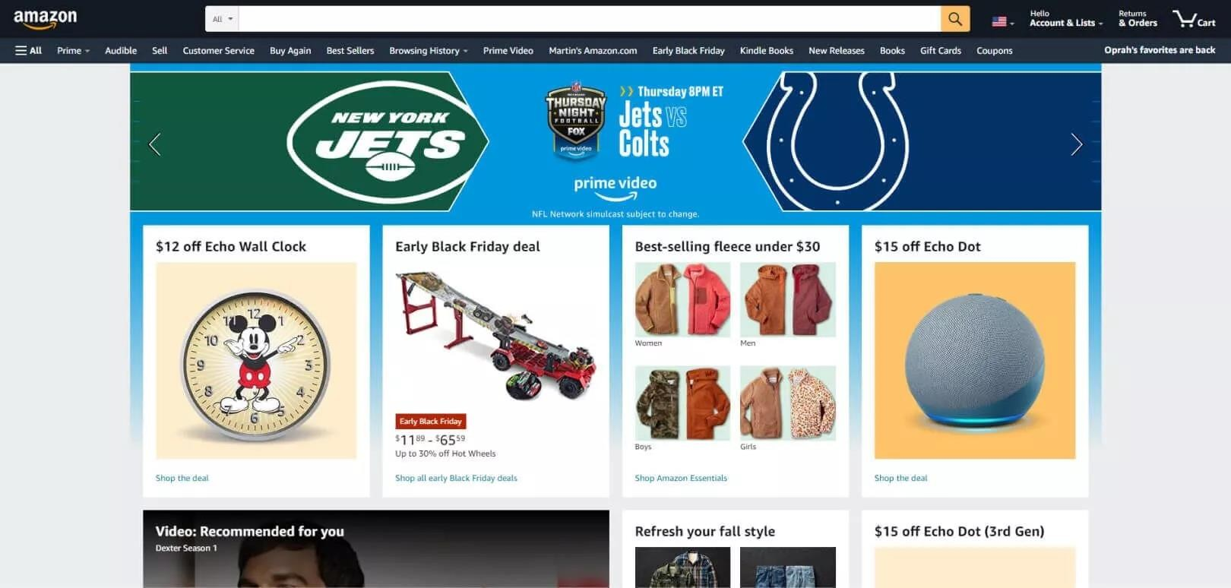

This allows visitors to concentrate on the category that they are most interested in and shop without any distractions, which means a better customer experience for them and an improved conversion rate for you.

### A person using a computer Description automatically generated with low confidenceOptimize Shopping Cart Functionality

To keep clients from forsaking their shopping baskets, you ought to guarantee that your shopping basket works well and is not difficult to explore. The method for understanding shortcomings is too much of the time to investigate the presentation.

Assess your examination information to see at which stages clients will more often than not drop off and conceptualize thoughts on the best way to further develop them. Then, utilize A/B testing to figure out which arrangement has the most noteworthy potential to diminish shopping basket deserting.

During the improvement cycle, focus on the client venture. Clear the checkout page and eliminate interruptions and additionally potential spots to exit. This will forestall any disarray during the checkout interaction. A lot of change studies have shown that the fewer snaps during checkout, the higher your transformation rate will be.

### Build Email Lists



If your eCommerce business methodology does exclude email showcasing as a correspondence channel, you are passing up enormous deals. Go through sign structures, and give something in return for an email address like a markdown code or even a little present. Ensure you win the client's trust and never convey messages without the client's assent, in any case, you risk ending up in the SPAM envelope and nobody needs to demolish their image like that.

### Improve Your Social Media Strategy

The online entertainment system your eCommerce promoting group gets ready ought to be associated with your substance technique. This implies reusing your site content across your web-based entertainment channels. as it will promise you a bigger crowd and lift your perceivability.

Social networks such as Instagram, TikTok, and YouTube are usually best for an eCommerce marketing strategy focused on selling products, however, don’t underestimate the power of Facebook, as the social media giant has over 2.89 billion monthly active users.